Computer Engineering Department - ITU
CE101L: Object Oriented Programming Lab

Course Instructor: Usama Bin Shakeel | Dated: 18/05/2022
Teaching Assistant: Aqsa Khalid | Semester: Spring 2022
Lab Engineer: Nadir Abbas | Batch: BSCE2021

Lab 10A. Problem Based Learning through Open Ended Questions

Name | Roll number | Report  (out of 100) | Scaled to 10 | Total  (out of 10)
Muhammad Abubakar Saif | BSCE21017

Checked on: ____________________________

Signature: ____________________________

Objective
The objective of this lab is to observe the basic knowledge of programming classes in C++.

Equipment and Component
Component Description | Value | Quantity
Computer | Available in lab | 1

Conduct of Lab
- Students are required to perform this experiment individually.
- In case the lab experiment is not understood, the students are advised to seek help from the course instructor, lab engineers, assigned teaching assistants (TA) and lab attendants.

Theory and Background
Open-ended problem is a problem that has several or many correct answers, and several ways to the correct answer(s). The Open-Ended Approach provides students with "experience in finding something new in the process"(Shimada 1997). It is basically facilitating the development of creative problem-solving skills.
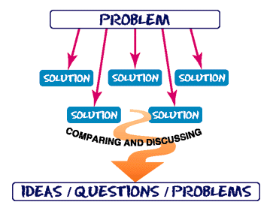
Figure 1: *What is Open Ended Problem Solving??

Lab Task

Task A: [Marks: 20]

Write a program to print the sum, difference and product of two complex numbers by creating a class named 'Complex' with separate methods for each operation whose real and imaginary parts are entered by user

(Complex.h)

#ifndef INC_2022_SPRING_TEMPLATE_CE_OOP_ASSIGNMENT_7_BSCE21017_COMPLEX_H
#define INC_2022_SPRING_TEMPLATE_CE_OOP_ASSIGNMENT_7_BSCE21017_COMPLEX_H
#include <iostream>
using namespace std;
class Complex {
private:
double real,imaginary;
public:
Complex();
Complex(double actual, double supposed);
void setComplex(int choice, double r = 0, double imagine = 0);
double getComplex(int choice);
void printComplexNo();
Complex addTwoComplexNo(Complex second);
Complex subtractTwoComplexNo(Complex second);
Complex multiplyTwoComplexNo(Complex second);
Complex divideTwoComplexNo(Complex second);
Complex getComplexConjugate();
Complex operator+ (Complex number);
Complex operator- (Complex number);
Complex operator* (Complex number);
Complex operator/ (Complex number);
void operator= (Complex number);
friend ostream &operator<<(ostream &output,Complex &test){
test.printComplexNo();
return output;
}
friend istream &operator>>(istream &input,Complex &test){
double real1, imaginary1;
// cout<<"Enter Complex Number \n";
cout<<"Enter Real Part: ";
cin>>real1;
cout<<"Enter Imaginary Part: ";
cin>>imaginary1;
test.setComplex(1 , real1);
test.setComplex(2 ,real1 , imaginary1);
return input;
}
};
#endif //INC_2022_SPRING_TEMPLATE_CE_OOP_ASSIGNMENT_7_BSCE21017_COMPLEX_H

(Complex.cpp)

#include "Complex.h"
#include <iostream>
using namespace std;
void Complex::setComplex(int choice, double r, double imagine) { //set the values of real and imaginary of Complex class
switch (choice) { //switch the cases based upon choice of user
case 1:
real = r; //saves the value of "r" in "real"
break; //breaks the case
case 2:
imaginary = imagine; //saves the value of "imagine" in "imaginary"
break; //breaks the case
}
return;
}
double Complex::getComplex(int choice) { //get the values of real and imaginary of Complex class
double value; //declares double-type variable
switch (choice) { //switch the cases based upon choice of user
case 1:
value = real; //saves the value of "real" in "value"
break;//breaks the case
case 2:
value = imaginary; //saves the value of "imaginary" in "value"
break; //breaks the case
}
return value; //returns the value to invoker function
}
Complex::Complex(double actual, double supposed) { //parameterized constructor definition
real = actual; //saves the value of "actual" in "real"
imaginary = supposed; //saves the value of "supposed" in "imaginary"
}
void Complex::printComplexNo() { //prints the Complex Number
cout /*<< "Complex Number: " */<< real << " + ";
if (imaginary < 0) { //if imaginary is negative then...
cout << "(" << imaginary << "i)";
} else cout << imaginary << "i";
return; //returns value to invoker function
}
Complex Complex::addTwoComplexNo(Complex second) { //add two complex numbers
Complex result; //declare instance of Complex class
result.real = real + second.real;
result.imaginary = imaginary + second.imaginary;
return result; //returns value to invoker function
}
Complex Complex::subtractTwoComplexNo(Complex second) { //subtract two complex numbers
Complex result; //declare instance of Complex class
result.real = real - second.real;
result.imaginary = imaginary - second.imaginary;
return result;//returns value to invoker function
}
Complex Complex::multiplyTwoComplexNo(Complex second) { //multiply two complex numbers
Complex product; //declare instance of Complex class
product.real = (real * second.real) - (imaginary * second.imaginary);
product.imaginary = (real * second.imaginary) + (imaginary * second.real);
return product; //returns value to invoker function
}
Complex Complex::divideTwoComplexNo(Complex second) { //divide two complex numbers
Complex quotient; //declare instance of Complex class
quotient.real = ((real * second.real) + (imaginary * second.imaginary)) /
((second.real * second.real) + (second.imaginary * second.imaginary));
quotient.imaginary = ((imaginary * second.real) - (real * second.imaginary)) /
((second.real * second.real) + (second.imaginary * second.imaginary));
return quotient; //returns the value to invoker function
}
Complex::Complex() { //default constructor
real = 0; //sets the value to ZERO
imaginary = 0; //sets the value to ZERO
}
Complex Complex::getComplexConjugate() { //find the conjugate of complex numbers
Complex conjugate; //declare instance of Complex class
conjugate.real = real;
conjugate.imaginary = (-1 * imaginary); //binds "-1" with imaginary part
return conjugate; //returns value to invoker function
}
Complex Complex::operator+(Complex number) { //addition operator overloading
Complex result; //declare instance of Complex class
result.real = real + number.real;
result.imaginary = imaginary + number.imaginary;
return result; //returns value to invoker function
}
Complex Complex::operator-(Complex number) { //subtraction operator overloading
Complex result; //declare instance of Complex class
result.real = real - number.real;
result.imaginary = imaginary - number.imaginary;
return result; //returns value to invoker function
}
Complex Complex::operator*(Complex number) { //multiplication operator overloading
Complex product; //declare instance of Complex class
product.real = (real * number.real) - (imaginary * number.imaginary);
product.imaginary = (real * number.imaginary) + (imaginary * number.real);
return product; //returns value to invoker function
}
Complex Complex::operator/(Complex number) { //division operator overloading
Complex quotient; //declare instance of Complex class
quotient.real = ((real * number.real) + (imaginary * number.imaginary)) /
((number.real * number.real) + (number.imaginary * number.imaginary));
quotient.imaginary = ((imaginary * number.real) - (real * number.imaginary)) /
((number.real * number.real) + (number.imaginary * number.imaginary));
return quotient; //returns value to invoker function
}
void Complex::operator=(Complex number) { //assignment operator overloading
// Complex copy;
real = number.real;
imaginary = number.imaginary;
// return copy;
}

(MAIN FUNCTION)

int main {
string rep; //declares variable of string-type
int opt; //declares variable of int-type
Complex test; //declares the instance of Complex class
update: //"GOTO" label
system("clear"); //clear the screen
cout << "Enter First Complex Number: \n";
cin >> test; //takes input from user
Complex t1, result; //takes instance
cout << "Enter Second Complex Number: \n";
cin >> t1; //takes input from user
again: //"GOTO" label
system("clear"); //clear the screen
cout << "1. Print Complex Number \n";
cout << "2. Add Two Complex Number \n";
cout << "3. Subtract Two Complex Number \n";
cout << "4. Multiply Two Complex Number \n";
cout << "5. Divide Two Complex Number \n";
// cout << "6. Get Conjugate of Complex Number \n";
cout << "6. Print Resultant Complex Number \n";
cout << "7. Get Real Number \n";
cout << "8. Get Imaginary Number \n";
cout << "Enter Your Choice: ";
cin >> opt; //takes input from the user
switch (opt) { //switch the cases based upon user choice
case 1: {
cout << "1. Print First Complex Number \n";
cout << "2. Print Second Complex Number \n";
cout << "3. Print Resultant Complex Number \n";
cout << "4. Print All of the Above \n";
cout << "Enter Your Choice: ";
cin >> opt; //takes input from the user
switch (opt) { //switch the cases based upon user choice
case 1:
test.printComplexNo(); //calls the member function to print Complex Number
cout << endl; //makes a new line on console screen
break;
case 2:
t1.printComplexNo(); //calls the member function to print Complex Number
cout << endl; //makes a new line on console screen
break;
case 3:
result.printComplexNo(); //calls the member function to print Complex Number
cout << endl; //makes a new line on console screen
break;
case 4:
cout << "First Complex Number: " << test << endl;
cout << "Second Complex Number: " << t1 << endl;
cout << "Resultant Complex Number: " << result << endl;
break;
}
break; //breaks the case
}
case 2: {
result = test.addTwoComplexNo(t1); //calls the member function to add two Complex Number
cout << " (" << test << ") + (" << t1 << ") = " << result << endl;
break;
}
case 3: {
result = test.subtractTwoComplexNo(t1); //calls the member function to subtract two Complex Number
cout << " (" << test << ") - (" << t1 << ") = " << result << endl;
break;
}
case 4: {
result = test.multiplyTwoComplexNo(t1); //calls the member function to multiply two Complex Number
cout << " (" << test << ") x (" << t1 << ") = " << result << endl;
break;
}
case 5: {
result = test.divideTwoComplexNo(t1); //calls the member function to divide two Complex Number
cout << " (" << test << ") / (" << t1 << ") = " << result << endl;
break;
}
case 6: {
cout << result; //calls the cout operator overload to print Complex Number
break;
}
case 7:
cout<<"Real Number of First Complex Number: "<<test.getComplex(1) <<endl; //calls the member function to print complex part of Complex Number
cout<<"Real Number of Second Complex Number: "<<t1.getComplex(1) <<endl; //calls the member function to print complex part of Complex Number
cout<<"Real Number of Resultant Complex Number: "<<result.getComplex(1) <<endl; //calls the member function to print complex part of Complex Number
break;
case 8:
cout<<"Imaginary Number of First Complex Number: "<<test.getComplex(2) <<endl; //calls the member function to print imag. num of Complex Number
cout<<"Imaginary Number of Second Complex Number: "<<t1.getComplex(2) <<endl; //calls the member function to print imag. num of Complex Number
cout<<"Imaginary Number of Resultant Complex Number: "<<result.getComplex(2) <<endl; //calls the member function to print imag. num of Complex Number
break;
}
cout << endl << "Do you want to use the Complex Number Calculator again? \n";
cout << "If yes, then tell whether you want to reuse complex numbers or enter new complex numbers : \n";
cout << "Enter E to exit the calculator, R to reuse previous values, N to enter new complex numbers \n";
cin >> rep; //takes input from user
if (rep == "E" or rep == "e") {
return 0; //breaks the case
} else if (rep == "R" or rep == "r") {
goto again; //redirects to "again" label
} else if (rep == "N" or rep == "n") {
goto update; //redirects to "update" label
}
}

Output:

Taking Input:
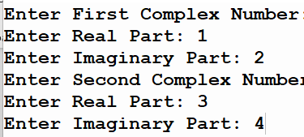
Displaying Complex Numbers:
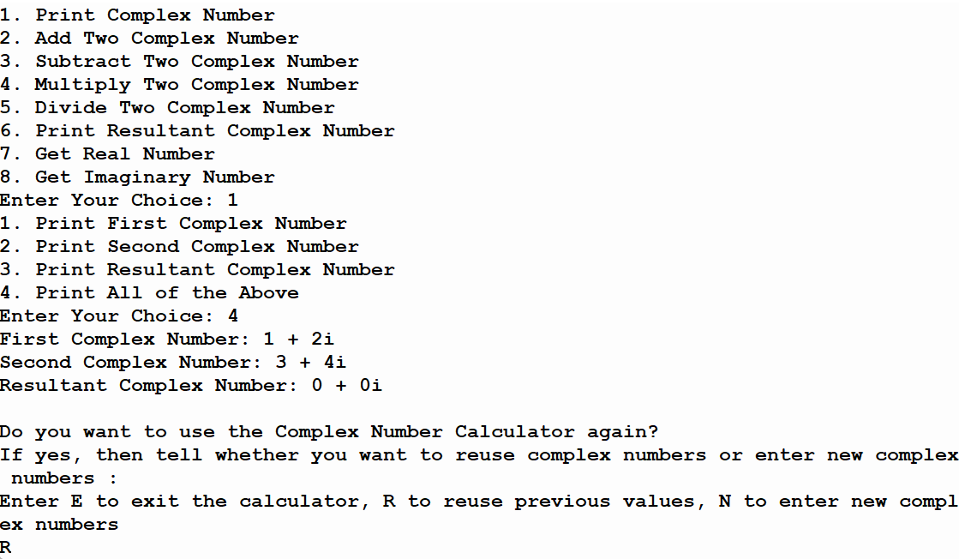
Addition:
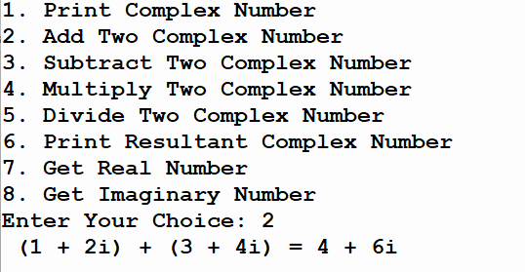

Subtraction:
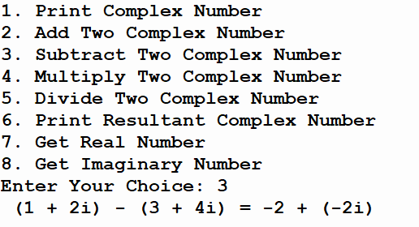
Multiplication:
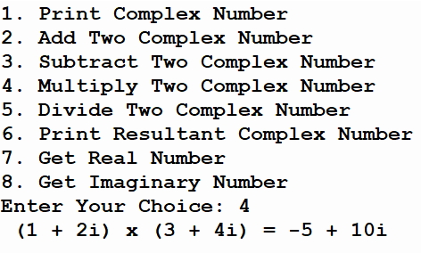
Division:
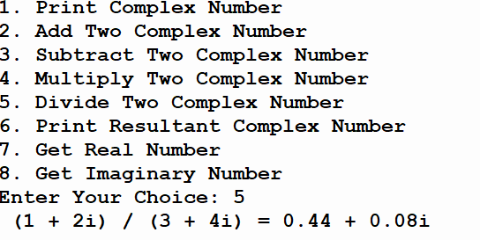

Task B: [Marks: 20]

Write a program in which you have to create a class that has variables to store Car data like; CarModel, CarName, CarPrice and CarOwner. The program should include functions to assign user defined values to the above-mentioned variable and a display function to show the values. Write a main that calls these functions. Now write another runner class that declares three Car objects and displays the data of all three.

(Car.h)

#ifndef INC_2022_SPRING_CE_OOP_WEEK10_LABTASK_A_BSCE21017_CAR_H
#define INC_2022_SPRING_CE_OOP_WEEK10_LABTASK_A_BSCE21017_CAR_H
#include <iostream>
#include <string>
using namespace std;
class Car {
private:
string carModel, carName, carOwner;
int carPrice;
public:
void setter(int choice, string test, int value = 0) {
switch (choice) {
case 1:
// cout<<"Car Name: "<<carName<<endl;
carName = test;
break;
case 2:
// cout<<"Car Owner: "<<carOwner<<endl;
carOwner = test;
break;
case 3:
carModel = test;
// cout<<"Car Model: "<<carModel<<endl;
break;
case 4:
carPrice = value;
// cout<<"Car Price: "<<carPrice<<endl;
break;
}
return;
}
void display(){
cout<<"Car Name: "<<carName<<endl;
cout<<"Car Owner: "<<carOwner<<endl;
cout<<"Car Model: "<<carModel<<endl;
cout<<"Car Price: "<<carPrice<<endl;
return;
}
};
class Runner{
public:
Car a;
Car b;
Car c;
~Runner(){
cout<<"\nDisplay: \n";
cout<<"First Object: \n";
a.display();
cout<<"Second Object: \n";
b.display();
cout<<"Third Object: \n";
c.display();
}
};
#endif //INC_2022_SPRING_CE_OOP_WEEK10_LABTASK_A_BSCE21017_CAR_H

(MAIN FUNCTION)

int main {
Runner r1;
cout<<"Enter Credentials of first object of Car: \n";
cout<<"Enter Car Owner Name: ";
cin.ignore(); //ignores the previous cin
getline(cin,test); //takes a string line from the user
r1.a.setter(2,test); //calls setter function to set the value in the member variable of class
cout<<"Enter Car Name: ";
// cin.ignore();
getline(cin,test); //takes a string line from the user
r1.a.setter(1,test); //calls setter function to set the value in the member variable of class
cout<<"Enter Car Model: ";
// cin.ignore();
getline(cin,test); //takes a string line from the user
r1.a.setter(3,test); //calls setter function to set the value in the member variable of class
cout<<"Enter Car Price: ";
// cin.ignore();
cin>>price; //takes input from user
r1.a.setter(4,test,price); //calls setter function to set the value in the member variable of class
cout<<"Enter Credentials of second object of Car: \n";
cout<<"Enter Car Owner Name: ";
cin.ignore(); //ignores the previous cin
getline(cin,test); //takes a string line from the user
r1.b.setter(2,test); //calls setter function to set the value in the member variable of class
cout<<"Enter Car Name: ";
// cin.ignore();
getline(cin,test); //takes a string line from the user
r1.b.setter(1,test); //calls setter function to set the value in the member variable of class
cout<<"Enter Car Model: ";
// cin.ignore();
getline(cin,test); //takes a string line from the user
r1.b.setter(3,test); //calls setter function to set the value in the member variable of class
cout<<"Enter Car Price: ";
// cin.ignore();
cin>>price; //takes input from user
r1.b.setter(4,test,price); //calls setter function to set the value in the member variable of class
cout<<"Enter Credentials of third object of Car: \n";
cout<<"Enter Car Owner Name: ";
cin.ignore(); //ignores the previous cin
getline(cin,test); //takes a string line from the user
r1.c.setter(2,test); //calls setter function to set the value in the member variable of class
cout<<"Enter Car Name: ";
// cin.ignore();
getline(cin,test); //takes a string line from the user
r1.c.setter(1,test); //calls setter function to set the value in the member variable of class
cout<<"Enter Car Model: ";
// cin.ignore();
getline(cin,test); //takes a string line from the user
r1.c.setter(3,test); //calls setter function to set the value in the member variable of class
cout<<"Enter Car Price: ";
// cin.ignore();
cin>>price; //takes input from user
r1.c.setter(4,test,price); //calls setter function to set the value in the member variable of class
return 0;
}

Output:

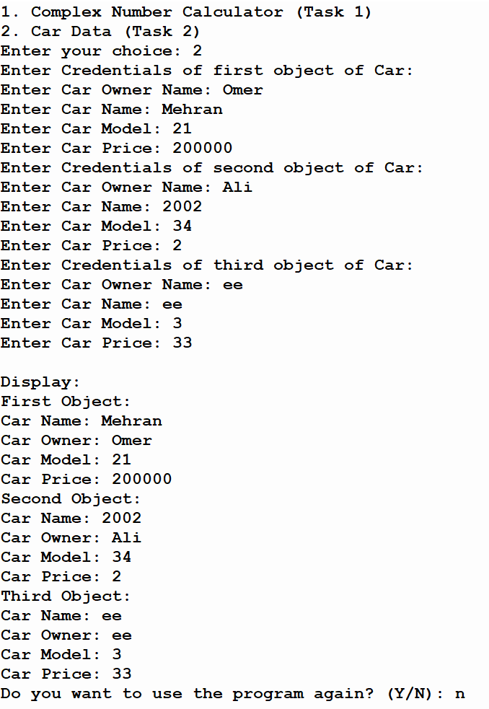

Assessment Rubric for Lab
Method for assessment:

Lab reports and instructor observation during lab sessions. Outcome assessed:
a. Ability to conduct experiments, as well as to analyze and interpret data (P) b. Ability to function on multi-disciplinary teams (A)
c. Ability to use the techniques, skills, and modern engineering tools necessary for engineering practice (P)
Performance metric | Task | CLO | Description | Max marks | Exceeds expectation | Meets expectation | Does not meet expectation | Obtained marks
1. Realization of experiment (a) | 1 | 1 | Functionality | 40 | Executes without errors excellent user prompts, good use of symbols, spacing in output. Through testing has been completed (35-40) | Executes without errors, user prompts are understandable, minimum use of symbols or spacing in output. Some testing has been completed (20-34) | Does not execute due to syntax errors, runtime errors, user prompts are misleading or non-existent. No testing has been completed (0-19)
2. Teamwork (b) | 1 | 3 | Group Performance | 5 | Actively engages and cooperates with other group member(s) in effective manner (4-5) | Cooperates with other group member(s) in a reasonable manner but conduct can be improved (2-3) | Distracts or discourages other group members from conducting the experiment (0-1)
3. Conducting experiment (a, c) | 1 | 1 | On Spot Changes | 10 | Able to make changes (8-10) | Partially able to make changes (5-7) | Unable to make changes (0-4)
 | 1 | 1 | Viva | 10 | Answered all questions (8-10) | Few incorrect answers (5-7) | Unable to answer all questions (0-4)
4. Laboratory safety and disciplinary rules (a) | 1 | 3 | Code commenting | 5 | Comments are added and does help the reader to understand the code (4-5) | Comments are added and does not help the reader to understand the code (2-3) | Comments are not added (0-1)
5. Data collection (c) | 1 | 3 | Code Structure | 5 | Excellent use of white space, creatively organized work, excellent use of variables and constants, correct identifiers for constants, No line-wrap (4-5) | Includes name, and assignment, white space makes the program fairly easy to read. Title, organized work, good use of variables (2-3) | Poor use of white space (indentation, blank lines) making code hard to read, disorganized and messy (0-1)
6. Data analysis (a, c) | 1 | 4 | Algorithm | 20 | Solution is efficient, easy to understand, and maintain (15-20) | A logical solution that is easy to follow but it is not the most efficient (6-14) | A difficult and inefficient solution (0-5)
7. Computer use (c) | 1 | 2 | Documentation & GitHub Submissions | 5 | Timely (4-5) | Late (2-3) | Not done (0-1)
 | Max Marks (total): |  |  | 100 | Obtained Marks (total):

Lab Engineer Signature: ________________________

